**Percentile and outliers:**

**The information between percentile:**

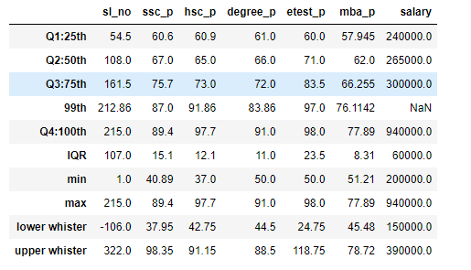

In the SSC pass data, the separation between the median and the lower median is 6.4. The disparity between the third quartile and the second quartile is 8.3. Subtracting the 75th percentile from the 100th percentile results in a margin of 13.7, representing the upper quartile's high point at the 25th percentile. Among the upper quartile data points, the interval between the 99th and 100th percentiles is 2.4.

In the HSC pass data, the separation between the median and the lower median is 4.1. The disparity between the third quartile and the second quartile is 8.0. Subtracting the 75th percentile from the 100th percentile results in a margin of 24.7, representing the upper quartile's high point at the 25th percentile. Among the upper quartile data points, the interval between the 99th and 100th percentiles is 5.84.

In the degree pass data, the separation between the median and the lower median is 5.0. The disparity between the third quartile and the second quartile is 6.0. Subtracting the 75th percentile from the 100th percentile results in a margin of 19.0, representing the upper quartile's high point at the 25th percentile. Among the upper quartile data points, the interval between the 99th and 100th percentiles is 7.14.

In the E-test pass data, the separation between the median and the lower median is 11.0. The disparity between the third quartile and the second quartile is 12.5. Subtracting the 75th percentile from the 100th percentile results in a margin of 14.5, representing the upper quartile's high point at the 25th percentile. Among the upper quartile data points, the interval between the 99th and 100th percentiles is 1.0.

In the MBA pass data, the separation between the median and the lower median is 4.05. The disparity between the third quartile and the second quartile is 4.255. Subtracting the 75th percentile from the 100th percentile results in a margin of 11.635, representing the upper quartile's high point at the 25th percentile. Among the upper quartile data points, the interval between the 99th and 100th percentiles is 1.78.

In the salary data, the separation between the median and the lower median is 25,000. The disparity between the third quartile and the second quartile is 35000. Among the upper quartile data points, the interval between the 99th and 100th percentiles is 6,40,000.

From the above observation, information has come to now is lower average student are more so we have to concentrate in those students to score more for increases they percentile.

The outliers of the dataset:

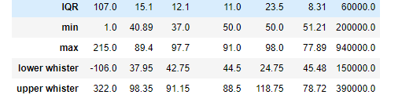

In the SSC pass data points, there are no outliers because both the lowest(40.891) score and highest(89.4) score are within the lower(37.94) and upper(98.35) whistler range.

In the HSC pass data set, there are outliers because both the minimum (37.0) mark and maximum (97.7) marks are between the lower(42.75) and upper(91.15) whistler range.

In the degree pass data, there are outliers in the upper level of the data because the maximum(91.0) score lies outside the upper(88.5) whistler range.

In the E-test pass data points, there are no outliers because both the lowest(50.0) score and highest(98.0) score are within the lower(24.75) and upper(118.75) whistler range.

In the MBA pass data points, there are no outliers because both the lowest(51.21) score and highest(77.89) score are within the lower(45.48) and upper(78.72) whistler range.

In the salary data, there are outliers in the upper level of the data because the maximum(9,40,000) score lies outside the upper(3,90,000) whistler range.

.